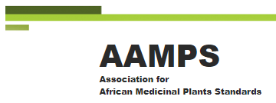

11 July 2021

In the case of a new monograph like C, erythrea then one would need to use the same outline format and fill in each paragraph. ( You may indeed think that the difference between C. Erythrea and C.Myrrha is NOT sufficiently large (especially in terms of traditional and modern usage ) that it does not warrant a separate monograph in which case one would just add sections to the C.Myrrha monograph

3-5 samples of the 150m grams from different known locations need to be collected. These will be couriered to CAMAG in Switzerland. CAMAG is our analytical partner who will use HPTLC to analyse all AfHP 2 plants. They will give you their courier account details for pick up.

I think I sent you the old C.Myrrha monograph but here it is again along with a guidance note which Thomas has prepared

Each author will be named under each monograph along with any affiliation they choose. Although authors get no fees they will get a free copy of the book and a significant proportion (30% + but not yet decided ) of any sales revenue of the INDIVIDUAL monographs sold on the AAMPS/Pharmaconnect Africa website and other social media platforms

Yours sincerely
David R. Katerere (Prof)
Trustee, PharmaConnect Africa
Director, African Association of Medicinal Plant Standards (AAMPS)
Co-Editor, African Herbal Pharmacopiea

