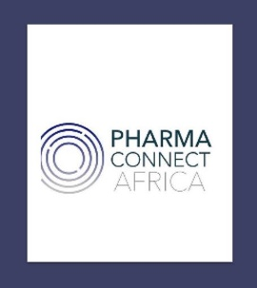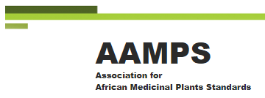

11 July 2021

Dr Julia Wieb
Chief Scientific Officer, Nektium
Dear Julia
RE: Sponsorship for AfHP monograph(s)
We would like to thank you for the sponsorship made to the African Association of Medicinal Plant Standards (AAMPS). The amount of 2000 euros will be utilized for the preparation of the monographs for Honeybush and Aframomum in the pharmacopeia.
We are grateful for your continuing support in bringing this project to fruition. Please note that communication about sponsorship to the public will not be specific to a monograph as this could lead to suspicion of bias. We trust that you understand this mutually beneficial decision.

Yours sincerely
David R. Katerere (Prof)
Trustee, PharmaConnect Africa
Director, African Association of Medicinal Plant Standards (AAMPS)
Co-Editor, African Herbal Pharmacopiea

